# Required Components

|  |  |  |  |  |  |  |  |  |
| --- | --- | --- | --- | --- | --- | --- | --- | --- |
| 1 | Joystick Unit | QTY 1 | 2 | USB-C cable | QTY 1 | 3 | Adafruit QT Py SAMD21 board | QTY 1 |
| A photo of the generic PS2 joystick module. | | | A photo of a black USB-C cable on a white background. | | |  | | |
| 4 | 3.5mm mono jack, panel mount | QTY 3 | 5 | Slide Switch | QTY 1 | 6 | Right angle 5 pin female header | QTY 1 |
| MJ-3502 | | | OS102011MA1QS1 | | |  | | |
| 7 | Female header, 7 pin | QTY 2 | 8 | #4-3/8” Sheet metal screw, self threading | QTY 4 | 9 | 24AWG solid core wire, multiple colours | Length:  2 feet |
|  | | | A photo of four metal #4 3/8" screws. | | |  | | |
| 10 | 4” cable tie | QTY 1 | 11 | M3 hex nuts | QTY 2 | 12 | 3D PCB | QTY 1 |
| A photo of two cable ties. | | | A photo of two metal M3 hex nuts. | | |  | | |

|  |  |  |  |  |  |  |  |  |
| --- | --- | --- | --- | --- | --- | --- | --- | --- |
| 13 | 3D Printed Enclosure Bottom | QTY 1 | 14 | 3D Printed Enclosure Top | QTY 1 | 15 | 3D Printed Slide Switch | QTY 1 |
|  | | |  | | |  | | |

# Required Tools

* Flush Cutters
* Wire Strippers
* Soldering Iron
* Philips Head Screwdriver
* Computer with USB port and Arduino IDE (or ability to install it)

# Required Personal Protective Equipment (PPE)

* Safety Goggles

# Assembly Instructions

## Step 1

|  |  |
| --- | --- |
| Insert components into 3D PCB:   * Press fit both 7 pin female headers so the tops are flush with the 3D print * Press fit slide switch so top is flush with 3D print * If possible, use pliers to bend the two outer mounting legs outwards to secure the slide switch * Snap fit right angle 5 pin female header with pins through hole * Press in the mono jacks so the tops are flush with the 3D print and install nuts to secure them. | Red 3D printed circuit board with components installed. |

## Wiring

For the next steps, the following picture is the wiring diagram.

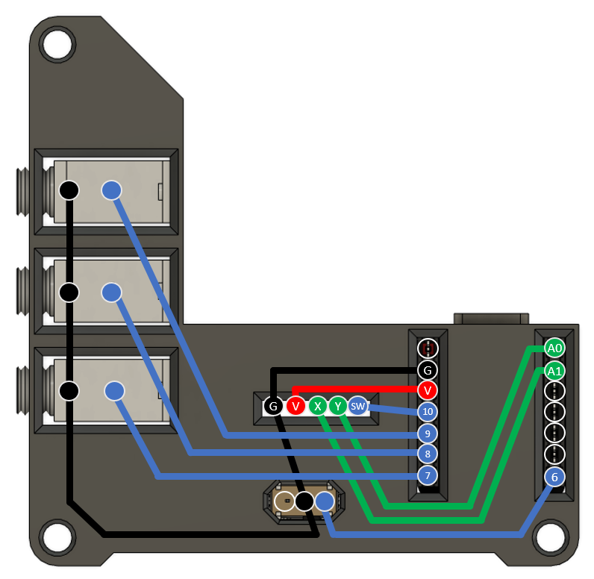

## Step 2

|  |  |
| --- | --- |
| Solder as shown. It is easiest to pre-tin wires and pins.  Ground pins (yellow) are:   * First pin on mono jack (closest to jack) * Middle pin on slide switch * Left pin on joystick header * 2nd pin from top left on QT Py header   Other connections:   * Joystick 5V to QT Py 3V3 * Joystick X to QT Py A1 * Joystick Y to QT Py A0 | Bottom of enclosure with 3D printed circuit board with some of the wiring. |

## Step 3

|  |  |
| --- | --- |
| Solder remaining connections.   * Joystick switch to QT Py D10 * Top mono jack middle pin to QT Py pin 9 * Middle mono jack middle pin to QT Py pin 8 * Bottom mono jack middle pin to QT Py pin 7 * Slide switch right pin to QT Py pin 6 | Bottom of enclosure with 3D printed circuit board with all of the wiring completed. |

## Step 4

|  |  |
| --- | --- |
| Inspect the board and check that none of the connections are shorted.  There should be no bridges/connections between adjacent pins.  If you have a multimeter, you can use it to double check continuity. | WARNING: If pins are shorted they may damage the USB port on your computer.  Warning with solid fill |

## Step 5

|  |  |
| --- | --- |
| Solder male headers to Adafruit QT Py SAMD21 board.  Insert Adafruit QT Py board and joystick.  Make sure the USB port on the QT Py board is facing towards the joystick.  All components should be “upside down” when joystick is upright. | Top view of 3D printed circuit board with all components inserted including microcontroller and joystick. |

## Step 6

|  |  |
| --- | --- |
| Insert M3 nuts into captive nut slots.  You might need to use pliers to push the nuts in. | Bottom of enclosure with M3 nut being inserted. |

## Step 7

|  |  |
| --- | --- |
| Place the slide switch cover in the slot with the taller side/slot up. | Bottom of enclosure with slide switch installed. |

## Step 8

|  |  |
| --- | --- |
| Plug the USB-C cable into the Adafruit QT Py board.  Insert the 3D PCB into bottom of enclosure, the joystick should sit on the 4 posts.  You may need to move the slide switch cover so that it lines up with the slide switch and fits onto it.  Insert screws into the joystick board’s 4 screw holes. | Bottom of enclosure with 3D printed circuit board inserted, screws installed in joystick board and USB cable plugged into microcontroller on the right side. |

## Step 9

|  |  |
| --- | --- |
| Place the top onto the enclosure.  Screw in all 4 screws from the bottom. | Assembled joystick, isometric view.  Bottom of assembled joystick, showing 4 screw holes. |

# Programming Instructions

1. Setup Arduino IDE
   1. Download Arduino IDE for your operating system at <https://www.arduino.cc/en/software>
   2. Install Arduino IDE
2. Setup Core
   1. Open Arduino IDE
   2. Click on **File -> Preferences**
   3. Locate the text field that says **Additional Boards Manager URLs** beside it.
   4. Copy and paste the following link into the field as a new line:  
      [**https://adafruit.github.io/arduino-board-index/package_adafruit_index.json**](https://adafruit.github.io/arduino-board-index/package_adafruit_index.json)
   5. Click on **OK**
   6. Restart the Arduino IDE
   7. Open the **Boards Manager** option from the **Tools-> Board-> Boards Manager..., search for “Adafruit SAMD” and select “Adafruit SAMD Boards” by Adafruit**
3. **Install Libraries**
   1. Go to <https://github.com/cyborg5/TinyUSB_Mouse_and_Keyboard> and go to Code -> Download ZIP and then rename this ZIP folder “TinyUSB_Mouse_and_Keyboard”
   2. In the Arduino IDE, go to **Sketch -> Include Library -> Add .ZIP library** and then select the “TinyUSB_Mouse_and_Keyboard” ZIP folder (likely found in your Downloads)
   3. Go to **Tools -> Manage Libraries…,** search for “Flash Storage” and install the library “FlashStorage” by Arduino
4. Upload the Code to the joystick
   1. Open OpenAT_Joystick_Mouse_M0_Software_Cedar.ino with Open Arduino IDE.
   2. **Select Adafruit QT Py M0 (SAMD21) from Tools -> Board -> Adafruit SAMD Boards**
   3. Click on **Tools -> USB Stack** and select **Adafruit TinyUSB**
   4. Connect the joystick using the USB cable to the computer.
   5. Select the correct port from **Tools -> Port** menu.
   6. Verify and upload the code.

# Testing

1. Slide the mode switch to Joystick mode.
2. Connect the joystick using the USB C cable to the computer.
3. If using Windows, open “Set up USB Game Controllers” from the Control Panel. You can find this by searching your computer in the search bar next to the Windows icon.
4. Ensure that the joystick is registered as a game controller and select your joystick from the list and go to “Properties”.
5. Move your joystick and observe the movement of the cross hatch in the “Axes” window. Ensure it moves in the proper directions when you move the joystick (the arrow points in the up direction). If not, open the joystick and check your connections.
6. Using assistive switches plugged into each mono jack, activate each switch, and ensure that one of buttons 1-4 light up when you press the switch, and stops when you release the switch. If not, open the joystick and check your connections.